|  |
| --- |
| Experiment No. 9 |
| Implement Non-Restoring algorithm using c-programming |
| Name: Divya Pravin Davane |
| Roll Number: 18 |
| Date of Performance: |
| Date of Submission: |

Aim - To implement Non-Restoring division algorithm using c-programming.

Objective -

1. To understand the working of Non-Restoring division algorithm.
2. To understand how to implement Non-Restoring division algorithm using c- programming.

Theory:

In each cycle content of the register, A is first shifted and then the divisor is added or subtracted with the content of register A depending upon the sign of A. In this, there is no need of restoring, but if the remainder is negative then there is a need of restoring the remainder. This is the faster algorithm of division.

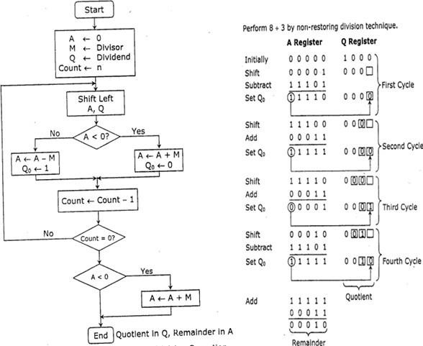

Program -

#include <stdio.h>

#include <stdlib.h>

int dec_bin(int, int []); int twos(int [], int []); int left(int [], int []); int add(int [], int []);

int main()

{ int a, b, m[4]={0,0,0,0}, q[4]={0,0,0,0}, acc[4]={0,0,0,0}, m2[4], i, n=4;

printf("Enter the Dividend: "); scanf("%d", &a); printf("Enter the Divisor: "); scanf("%d", &b); dec_bin(a, q); dec_bin(b, m); twos(m, m2); printf("\nA\tQ\tComments\n"); for(i=3; i>=0; i--)

{

printf("%d", acc[i]);

} printf("\t"); for(i=3; i>=0; i--)

{

printf("%d", q[i]);

}

printf("\tStart\n");

while(n>0)

{ left(acc, q);

for(i=3; i>=0; i--)

{

printf("%d", acc[i]);

} printf("\t"); for(i=3; i>=1; i--)

{

printf("%d", q[i]);

}

printf("_\tLeft Shift A,Q\n"); add(acc, m2); for(i=3; i>=0; i--)

{

printf("%d", acc[i]);

} printf("\t"); for(i=3; i>=1; i--)

{

printf("%d", q[i]);

}

printf("_\tA=A-M\n");

if(acc[3]==0)

{

q[0]=1; for(i=3; i>=0; i--)

{

printf("%d", acc[i]);

} printf("\t"); for(i=3; i>=0; i--)

{

printf("%d", q[i]);

}

printf("\tQo=1\n");

} else

{

q[0]=0; add(acc, m);

for(i=3; i>=0; i--)

{

printf("%d", acc[i]);

} printf("\t"); for(i=3; i>=0; i--)

{

printf("%d", q[i]);

}

printf("\tQo=0; A=A+M\n");

} n--;

}

printf("\nQuotient = "); for(i=3; i>=0; i--)

{

printf("%d", q[i]);

}

printf("\tRemainder = "); for(i=3; i>=0; i--)

{

printf("%d", acc[i]);

}

printf("\n");

return 0;

}

int dec_bin(int d, int m[])

{ int b=0, i=0;

for(i=0; i<4; i++)

{

m[i]=d%2;

d=d/2;

}

return 0;

}

int twos(int m[], int m2[])

{ int i, m1[4]; for(i=0; i<4; i++)

{

if(m[i]==0)

{

m1[i]=1;

} else

{

m1[i]=0;

}

} for(i=0; i<4; i++)

{

m2[i]=m1[i];

}

if(m2[0]==0)

{

m2[0]=1;

} else

{

m2[0]=0;

if(m2[1]==0)

{

m2[1]=1;

} else

{

m2[1]=0; if(m2[2]==0)

{

m2[2]=1;

} else

{

m2[2]=0;

if(m2[3]==0)

{

m2[3]=1;

}

else

{

m2[3]=0;

}

}

}

}

return 0;

}

int left(int acc[], int q[])

{ int i; for(i=3; i>0; i--)

{ acc[i]=acc[i-1];

}

acc[0]=q[3]; for(i=3; i>0; i--)

{ q[i]=q[i-1];

}

}

int add(int acc[], int m[])

{ int i, carry=0;

for(i=0; i<4; i++)

{

if(acc[i]+m[i]+carry==0)

{ acc[i]=0; carry=0;

}

else if(acc[i]+m[i]+carry==1)

{ acc[i]=1; carry=0;

}

else if(acc[i]+m[i]+carry==2)

{

acc[i]=0; carry=1;

}

else if(acc[i]+m[i]+carry==3)

{

acc[i]=1; carry=1;

}

}

return 0;

}

Output:

Enter the Dividend: 10

Enter the Divisor: 2

|  |  |  |
| --- | --- | --- |
| A | Q | Comments |
| 0000 | 1010 | Start |
| 0001 | 010_ | Left Shift A,Q |
| 1111 | 010_ | A=A-M |
| 0001 | 0100 | Qo=0; A=A+M |
| 0010 | 100_ | Left Shift A,Q |
| 0000 | 100_ | A=A-M |
| 0000 | 1001 | Qo=1 |
| 0001 | 001_ | Left Shift A,Q |
| 1111 | 001_ | A=A-M |
| 0001 | 0010 | Qo=0; A=A+M |
| 0010 | 010_ | Left Shift A,Q |
| 0000 | 010_ | A=A-M |
| 0000 | 0101 | Qo=1 |

Quotient = 0101 Remainder = 0000 Conclusion -

This experiment and code implementation of the Non-Restoring Division Algorithm have provided valuable insights into the world of binary division.We have demonstrated the algorithm's effectiveness in dividing binary numbers without the need for restoring operations, making it suitable for hardware implementations where efficiency is critical. This experiment has not only showcased the power of algorithmic optimization in digital computation but has also illustrated the practical application of non-restoring division as a reliable method for achieving precise binary division in a hardware context.